Lab 3

Part 1 (20%)
- Complete the Unit 4 – Gameplay Mechanics Tutorial lessons 4.1 to 4.4.
- You may build as Windows executable or WebGL. It may take few minutes to complete building.
- Extend the project by adding a feature where after collecting the powerup, it doesn’t activate until the player uses a “Fire” action. Use C# events to handle the input.
- Submit your work (compatible with Unity LTS 2022.3) on the tutorial on Github. Submit to individual repo assigned to you.
- Deadline for part 1: Fri 03/10/2025 @10.00am

Part 2 (80%)
- Work in pairs to develop a 3D game based on Star Defender 4, use specification below.
- Each student role must include preparing assets, writing\reviewing code, level design, testing and feedback.
- Document your code and submit a clean well-organised project.
- Submit your project on github. Submit the lab teamwork to the team repo.
- Submit the individual lab report on blackboard.
- You are required to demo your lab. Upload before TBD
- It is not required to use actual insect models. Use any assets you like, the look of the game is up to you.

Specifications
- The player can move horizontally along bottom of screen. The player cannot move outside screen.
- The game includes 3 waves of invaders. You can set these as separate levels or mix them in the same level.
  - First wave of invaders moves as a block. They move left and right across the screen and downwards, changing directions between right and left. They randomly shoot downwards.
  - Second wave moves in circular patterns. Invaders in this wave shoot downwards and can also hit and destroy the player themselves.
  - More dangerous invader moves freely in the space and shoots southwards in any angle.
- Player can fire bullets which damage an invader if hit (invader dies with two bullets) and receives points.
- The player will die if it collides with a bullet or other projectiles.
- Player has 3 lives. When the player respawns, it flashes for 2 seconds in which it is invulnerable.
- Powerup boxes occasionally drop towards player. If player picks one, its weapon is upgraded for 10 seconds.
- Screen should show score and lives left
- Use the new input system package only (disable the use of the old input manager in the project settings). The code should be loosely coupled from the type of input devices by using C# events.
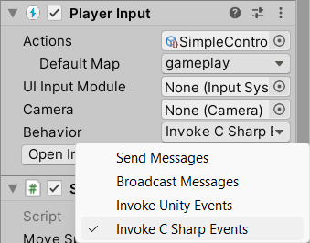

- Use appropriate audio effects for
  - Kill invader
  - Lose life
  - Player bullet fired

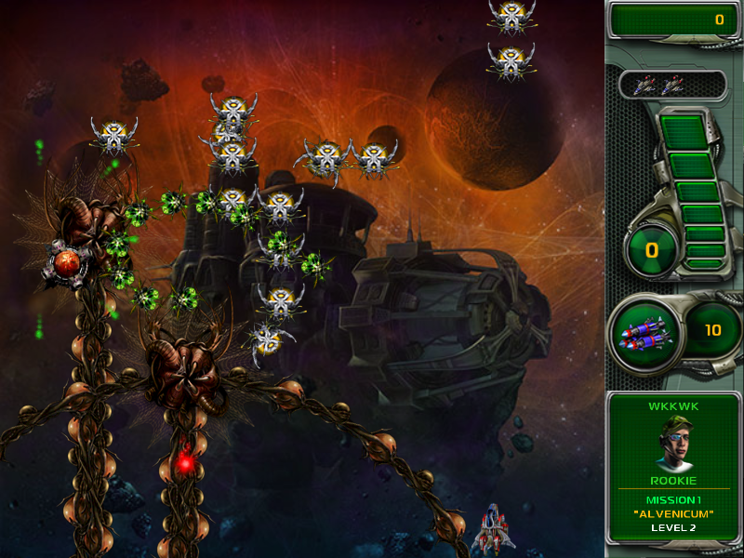
Figure. Star Defender 4

Report Requirements
- Each student individually writes a short report (400 words) to describe
  - Problems or issues faced in Part 1 if any, and how you solved them.
  - Role and Collaboration in Part 2: your role in the lab solution (i.e. contributed features) and collaboration with the other team member.
  - Evaluation: topics learned from Part 1 and Part 2, problems faced and evaluation of the results.

Marking Scheme
 | Score
Functional Features | 65 | Game functionality based on the specification  Input managed using C# events  Absence of code errors and bugs
Graphics Quality and Effects | 15 | Game design  Sound effects  Graphics quality
Documentation | 10 | Code structure and documentation  Directory structure of the project and Github repository  Report content and quality
Teamwork | 10 | Completing role tasks  Problem solving and exchange of ideas  Peer teaching and learning
Total | 100 | ……………………………

